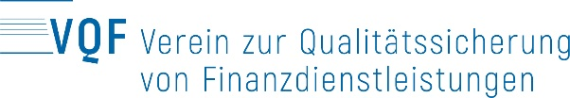 | VQF member No. | AMLA File No.

Declaration of identity of the beneficial owner (A)

Contracting partner:
The contracting partner hereby declares that the person(s) listed below is/are the beneficial owner(s) of the assets involved in the business relationship. If the contracting partner is also the sole beneficial owner of the assets, the contracting partner's detail must be set out below
Surname(s):
First name(s):
Date(s) of birth:
Nationality:
Actual address of domicile:
The contracting partner hereby undertakes to inform automatically of any changes to the information contained herein.

Date: |  | Signature(s):
It is a criminal offence to deliberately provide false information on this form (article 251 of the Swiss Criminal Code, document forgery)

